SIMATS ENGINEERING (SAVEETHA SCHOOL OF ENGINEERING)
Department of Artificial Intelligence and Machine Learning

ASSESSMENT TOOL 3 – Experiments (5 QUESTIONS)

Course Code: | MLA0407 | Course Title: | Deep Learning  Assessment Tool 3 – Experiments  (5 Questions × 10 Marks)
CO Assessed: | CO1 | Assessment:
Weightage: | 35% of CIA | Total Marks:
CO1 Statement: | Apply the fundamental concepts of machine learning and neural networks to design and analyze  learning algorithms using perceptrons, multilayer perceptrons, forward propagation, backpropagation, gradient descent optimization techniques, and Maximum Likelihood Estimation for solving real-world problems.
Student Name: | I. Leela Sravan Kumar | Reg. No.: | 192425272
Section / Batch: | 2024 | Date:

Code of Conduct
I I. Leela Sravan Kumar (192425272) (NAME/ REG NO) certify that this submission is my original work and that I have adhered to the guidelines specified for this assessment. I understand that any violation of academic integrity rules will result in disciplinary action. Signature of the Student:

QUESTIONS: 5 Total Marks: 50

Annexure A

Experiments Duration: 1hr

Experiment 1: Implementation of a Single Artificial neuron Objective: Implement a single artificial neuron using Python.
Task:
Develop a Python program to simulate an artificial neuron that accepts multiple inputs, computes the weighted sum, applies a step activation function, and generates the output. Test the neuron using different input combinations and analyze its behavior.

Input and output:
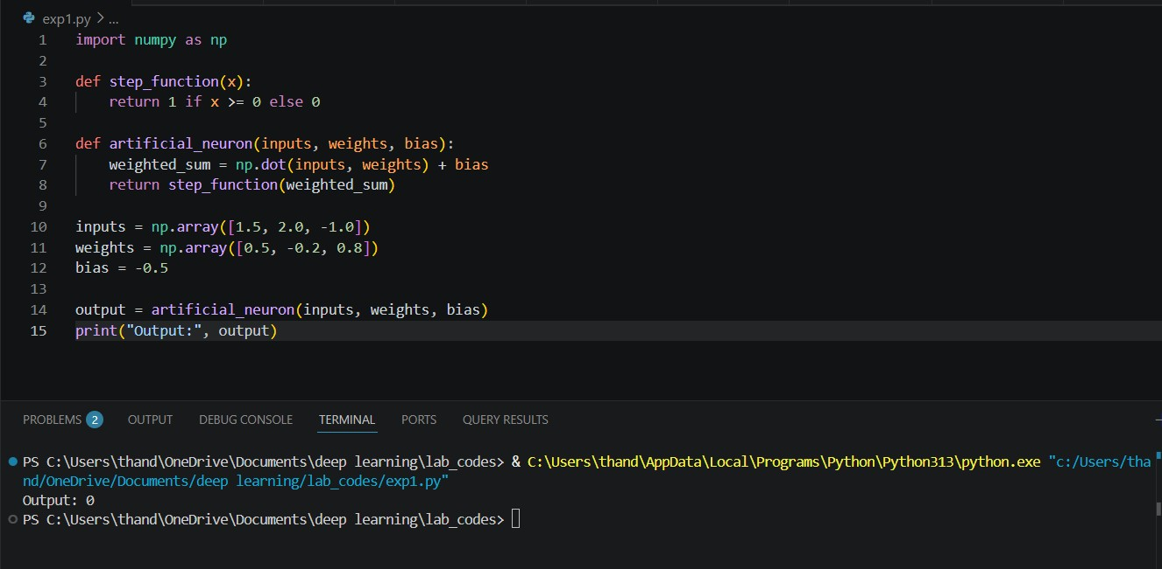

Experiment 2: Perceptron for AND Gate
Objective: Implement the Perceptron Learning Algorithm.
Task:
Write a Python program to implement a perceptron for the AND logic gate. Train the model using suitable weights and bias, display the final weights after training, and evaluate the prediction accuracy. Input and output:
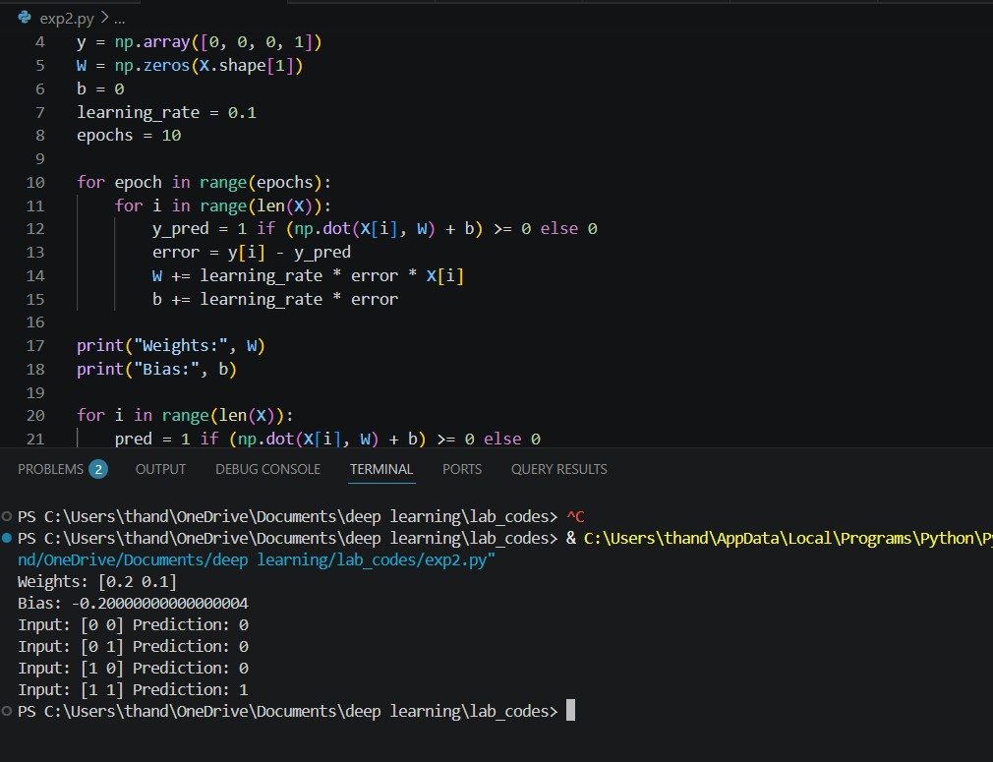

Experiment 3: Perceptron for OR Gate
Objective: Design a perceptron model for binary classification.
Task:
Implement a perceptron to classify the OR logic gate. Compare the training process and final weights with those obtained for the AND gate and analyze the differences. Input and output:
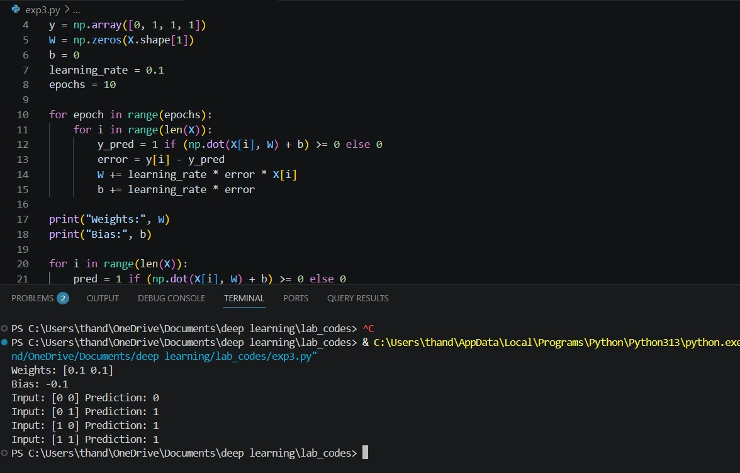

Experiment 4: XOR Classification Analysis
Objective: Study the limitations of a single-layer perceptron.
Task:
Attempt to train a perceptron for the XOR logic gate. Observe the results and explain why the perceptron fails to classify XOR correctly. Suggest an alternative neural network architecture capable of solving this problem. Input and output:
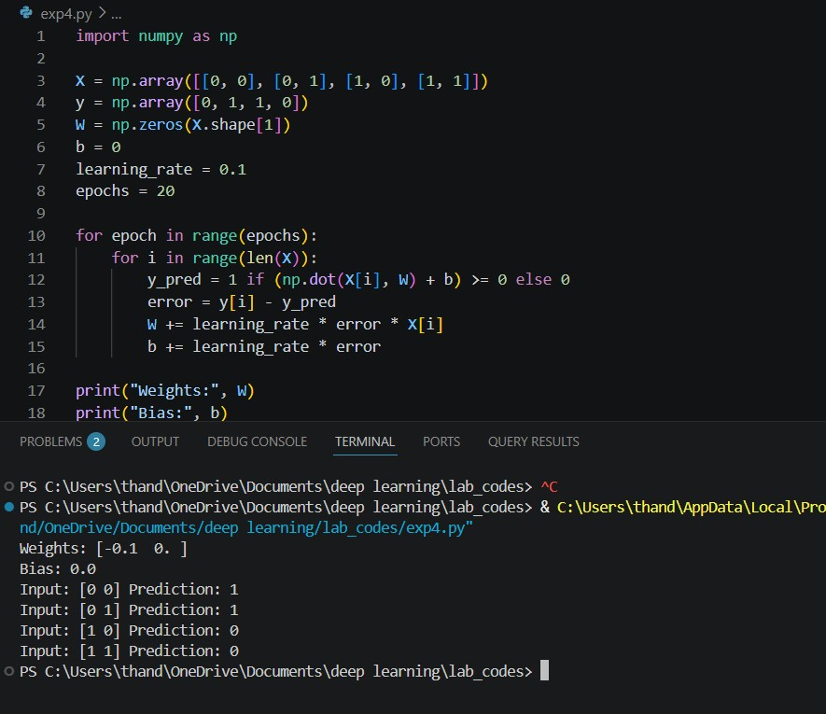

Experiment 5: Gradient Descent Optimization Objective: Understand Gradient Descent.
Task:
Implement the Gradient Descent algorithm to minimize a simple quadratic cost function. Plot the cost function against the number of iterations and analyze the convergence behavior for different learning rates.
Input and output:
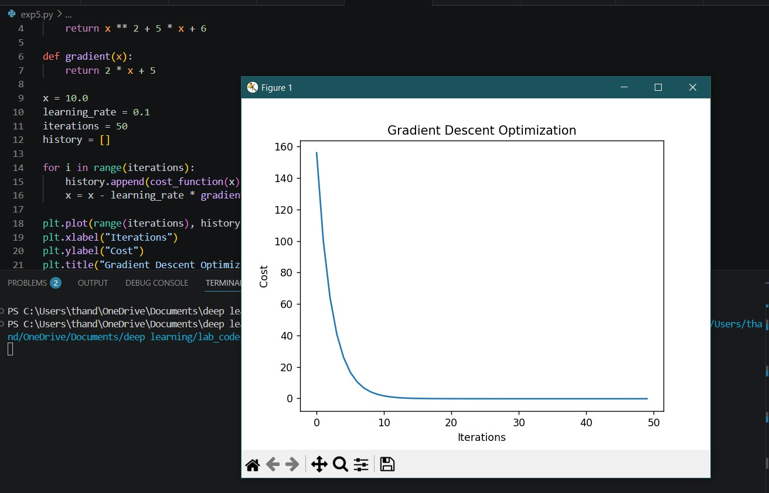

Experiment 6: Comparison of Optimization Techniques
Objective: Compare different optimization algorithms.
Task:
Implement Batch Gradient Descent, Stochastic Gradient Descent (SGD), and Mini-Batch Gradient Descent on the same dataset. Compare their execution time, convergence speed, and prediction performance. Present the findings in tabular form. Input and output:
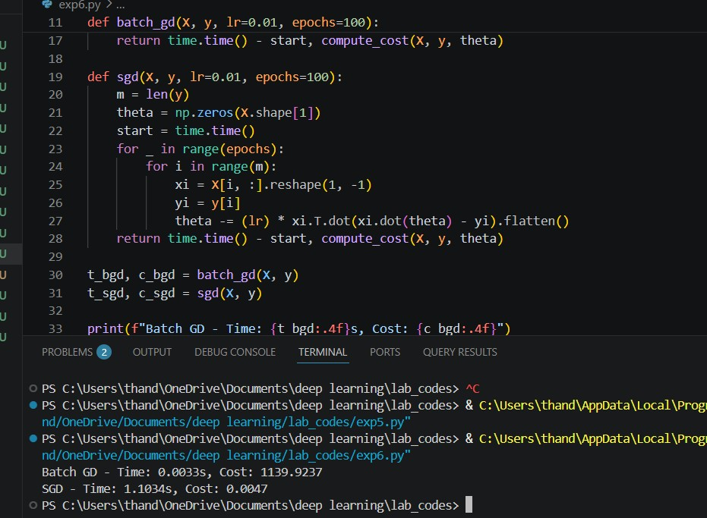

Experiment 7: Multilayer Perceptron (MLP) for Classification Objective: Build a simple Multilayer Perceptron.
Task:
Using TensorFlow/Keras or PyTorch, design and train an MLP model for the Iris dataset (or any standard dataset). Evaluate the model using accuracy, confusion matrix, and loss curves.

Input and output:

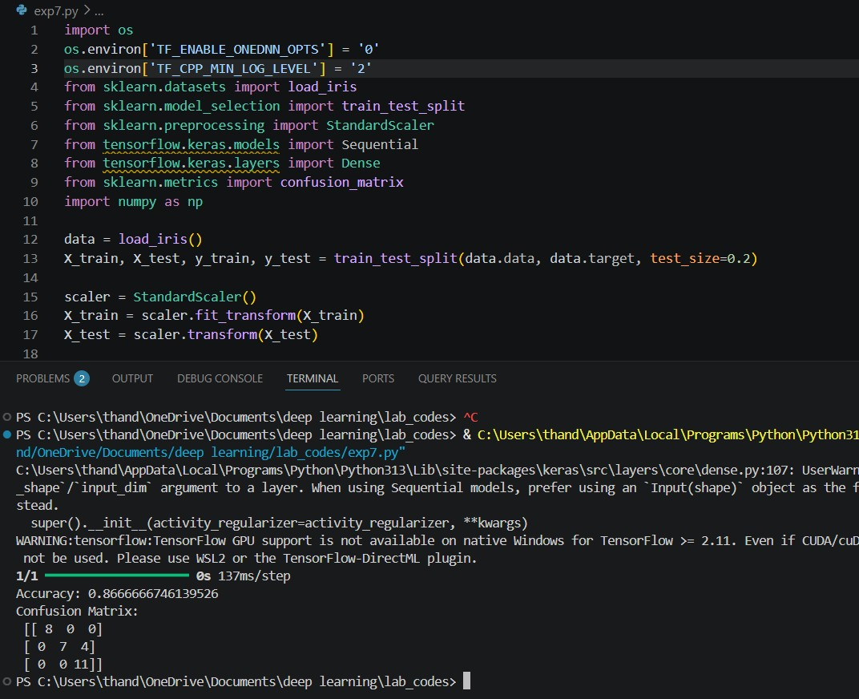

Experiment 8: Forward Propagation Demonstration Objective: Understand Forward Propagation.
Task:
Implement forward propagation for a neural network with one hidden layer. Display the weighted sums and activation values of each neuron. Verify the output manually for one sample and compare it with the program output. Input and output:
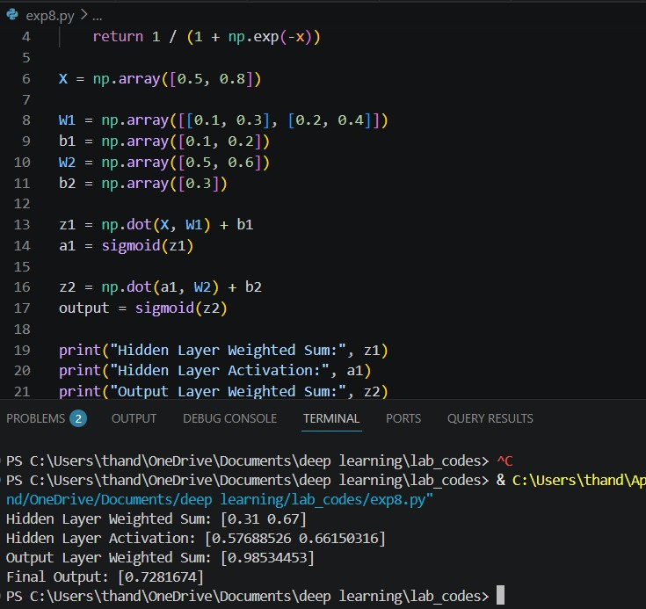

Experiment 9: Backpropagation Implementation
Objective: Study the Backpropagation Algorithm.
Task:
Train a small neural network using backpropagation for a binary classification problem. Observe the changes in weights after each epoch and analyze how backpropagation minimizes the error. Input and output:
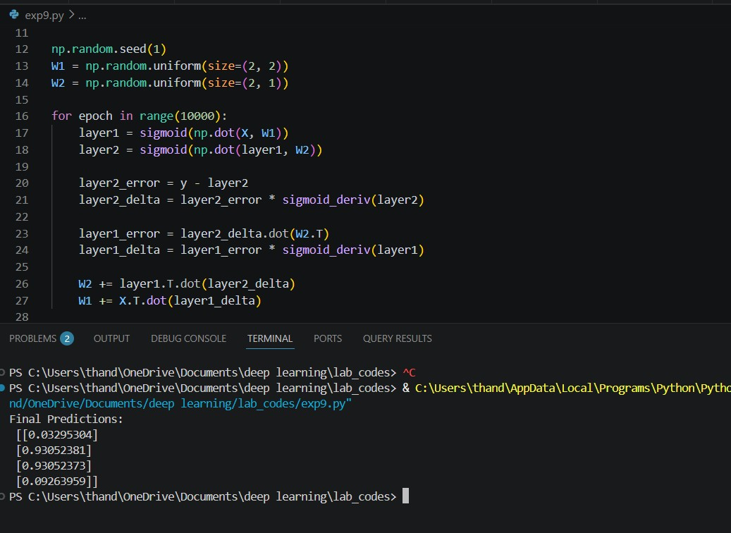

Experiment 10: Curse of Dimensionality Analysis Objective: Analyze the impact of high-dimensional data.
Task:
Create datasets with increasing numbers of input features. Train the same machine learning model on each dataset and compare training time, model accuracy, and computational complexity. Analyze how increasing dimensionality affects the model's performance and suggest techniques to overcome this issue.
Input and output:
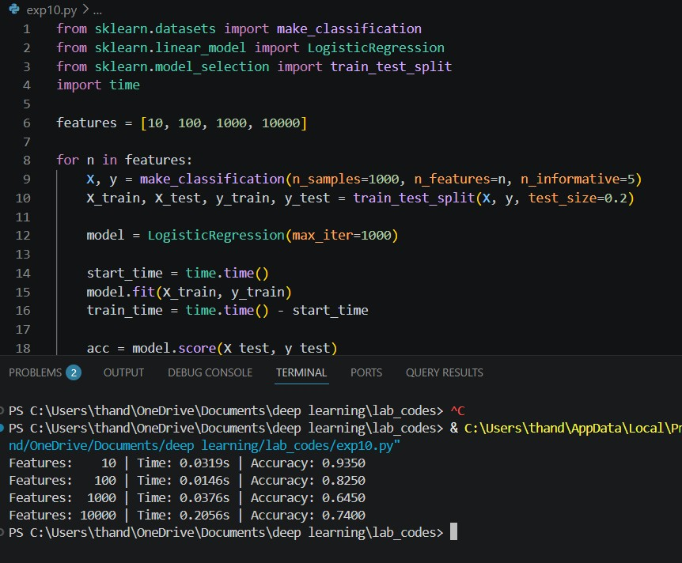

Rubrics for Calculation

Criteria | Weightage | Level 4 (Exemplary) | Level 3 (Proficient) | Level 2 (Developing) | Level 1 (Beginning)
Technical Content  Accuracy | 30 | Highly accurate, indepth, and  insightful technical explanation | Technically correct content  with adequate depth and clarity | Basic concepts presented with  limited accuracy and depth | Content contains major technical  errors; concepts poorly understood
Problem  Identification | 25 | Problem rigorously analyzed using  appropriate and advanced methods | Problem clearly defined with a logical  engineering approach | Problem  identified but analysis or  methodology is weak | Problem statement unclear or incorrect; no logical approach
Use of Tools | 20 | Advanced tools, wellanalyzed data, and highly effective visuals | Appropriate tools and data  used effectively with clear visuals | Limited use of tools and basic data  interpretation | Minimal or incorrect use of tools and data; poor visuals
Communication | 15 | Highly engaging, confident, and  audience-focused delivery | Clear, organized, and professional communication | Understandable but lacks clarity, structure, or confidence | Poor organization,  unclear speech, ineffective slides
Professionalism | 10 | Exemplary professionalism, leadership, and ethical awareness | Professional conduct with  effective team collaboration | Basic professionalism;  uneven team participation | Lacks professionalism; minimal  contribution or ethical  awareness

Faculty In-charge | Course Coordinator | Program Director
Signature: | Signature: | Signature:
Date: | Date: | Date:

